**Auxiliary Set**

**Time Limit: 9000/4500 MS (Java/Others)    Memory Limit: 65536/65536 K (Java/Others)**

**Problem Description**

Given a rooted tree with n vertices, some of the vertices are important.  
  
An auxiliary set is a set containing vertices satisfying at least one of the two conditions：  
  
∙It is an important vertex  
∙It is the least common ancestor of two different important vertices.  
  
You are given a tree with n vertices (1 is the root) and q queries.  
  
Each query is a set of nodes which indicates the **unimportant** vertices in the tree. Answer the size (i.e. number of vertices) of the auxiliary set for each query.

**Input**

The first line contains only one integer T (T≤1000), which indicates the number of test cases.  
  
For each test case, the first line contains two integers n (1≤n≤100000), q (0≤q≤100000).  
  
In the following n -1 lines, the i-th line contains two integers ui, vi(1≤ui, vi≤n) indicating there is an edge between ui and vi in the tree.  
  
In the next q lines, the i-th line first comes with an integer mi(1≤mi≤100000) indicating the number of vertices in the query set.Then comes with mi different integers, indicating the nodes in the query set.  
  
It is guaranteed that ∑qi=1 mi≤100000.  
  
It is also guaranteed that the number of test cases in which n≥1000   or ∑qi=1 mi≥1000 is no more than 10.

**Output**

For each test case, first output one line "Case #x:", where x is the case number (starting from 1).  
  
Then q lines follow, i-th line contains an integer indicating the size of the auxiliary set for each query.

**Sample Input**

1

6 3

6 4

2 5

5 4

1 5

5 3

3 1 2 3

1 5

3 3 1 4

**Sample Output**

Case #1:

3

6

3

***Hint***

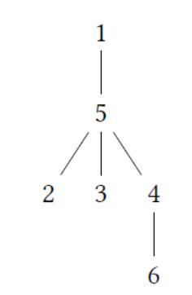

For the query {1，2, 3}:

•node 4, 5, 6 are important nodes For the query {5}：

•node 1，2, 3, 4, 6 are important nodes

•node 5 is the lea of node 4 and node 3 For the query {3, 1，4}:

• node 2, 5, 6 are important nodes

**Source**

[2016CCPC东北地区大学生程序设计竞赛 - 重现赛](http://acm.hdu.edu.cn/search.php?field=problem&key=2016CCPC%B6%AB%B1%B1%B5%D8%C7%F8%B4%F3%D1%A7%C9%FA%B3%CC%D0%F2%C9%E8%BC%C6%BE%BA%C8%FC+-+%D6%D8%CF%D6%C8%FC&source=1&searchmode=source)